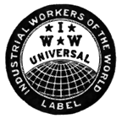 | IWW Solidarity Night | 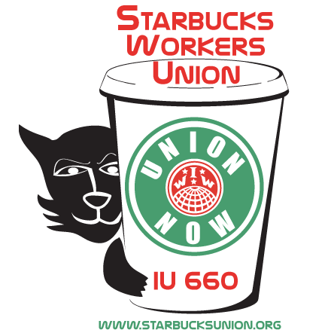

An Evening of Musical Entertainment to Benefit the
Starbucks Workers Union

Friday, November 17
8-11 p.m.
The Zeitgeist Gallery, 186 Hampshire Street, Cambridge

Featured performers (list in progress):

Jake and the Infernal Machine
Bill Bumpus

suggested donation: $10

Over the past year, four Starbucks employees in New York City have been fired for organizing with the Industrial Workers of the World (IWW), despite an NLRB settlement in March in which Starbucks agreed to respect baristas' right to form a union. The Boston branch of the IWW is raising funds to assist these workers in getting their jobs back and to support Starbucks organizing efforts in NY and elsewhere. For further information, call 617-625-9070, email bostgmb-l@iww.org , or visit www.starbucksunion.org.

Can't make it to the benefit? Please make checks out to the IWW Starbucks Workers Union and send them to:

IWW Starbucks Workers Union
347 Maujer St. Apt. #C
Brooklyn, NY 11206

Next IWW Solidarity Night: Saturday, January 6

labor donated

